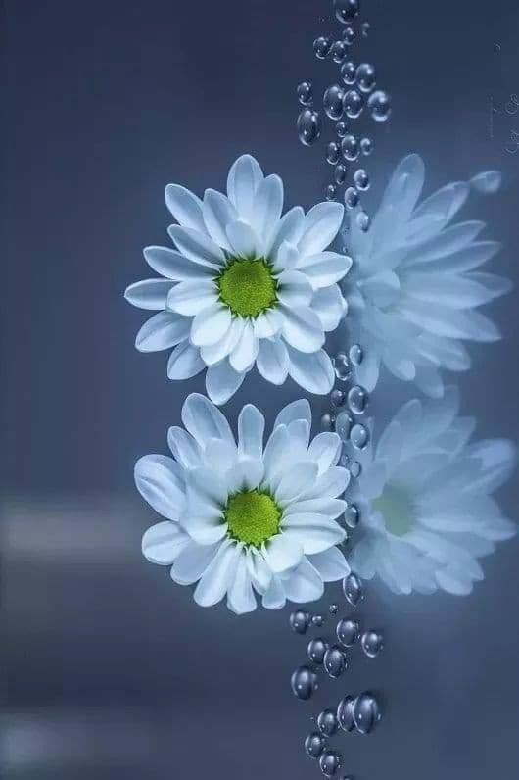:

Flower:2

Flweor1



Flower

Flower



Flower

Flower